Olusegun Afolabi
EECE 412
Professor Wenjie
2/18/2025

Lab 4
Part 1
Introduction
In this lab, we implemented a 2-to-4 decoder using selected signal assignment statements in VHDL. This builds on concepts from Lab 3 by mapping a 2-bit input ('ctrl') to a 4-bit output ('a') based on a predefined truth table. The goal was to write the VHDL code, analyze the RTL schematic, and compare it with an expected manually drawn multiplexer diagram.
Concept
A 2-to-4 decoder converts a 2-bit input into a one-hot 4-bit output, where only one output line is high for each input combination. The decoder functions similarly to a 4-to-1 multiplexer, selecting a specific output line based on the control signals. Selected signal assignments in VHDL are a concise and efficient method for implementing such logic.
Procedure:
- Created a new project in Vivado, selecting VHDL and the Basys 3 board.
- Wrote the VHDL code to implement the 2-to-4 decoder using selected signal assignments. Debugged the code multiple times to ensure accuracy of schematic result.
- Added the design file to the project and included the Basys 3 constraint file.
- Clicked 'Run Linter' and then opened the Elaborated Design.
- Opened the schematic and identified components, mapping them to the VHDL code.
- Compared the schematic with my manually drawn diagram.
- Concluded Part 1.
VHDL Code for decoder24_Afolabi design file:

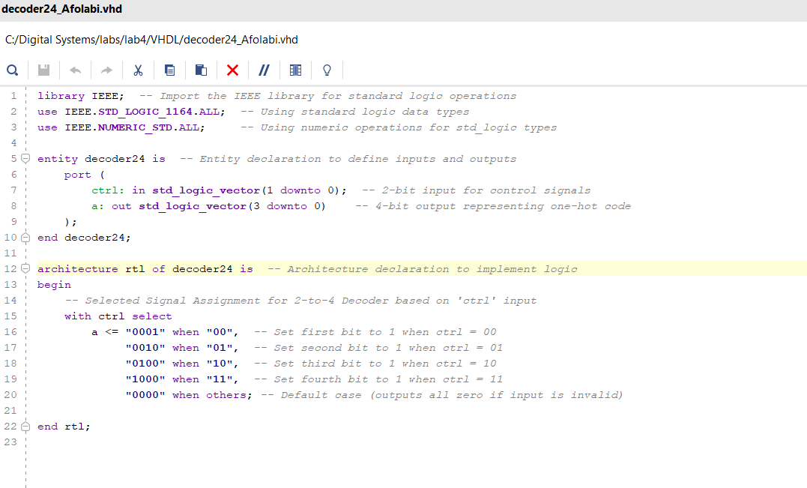
Schematic After Running Linter & Opening Elaborated Design:
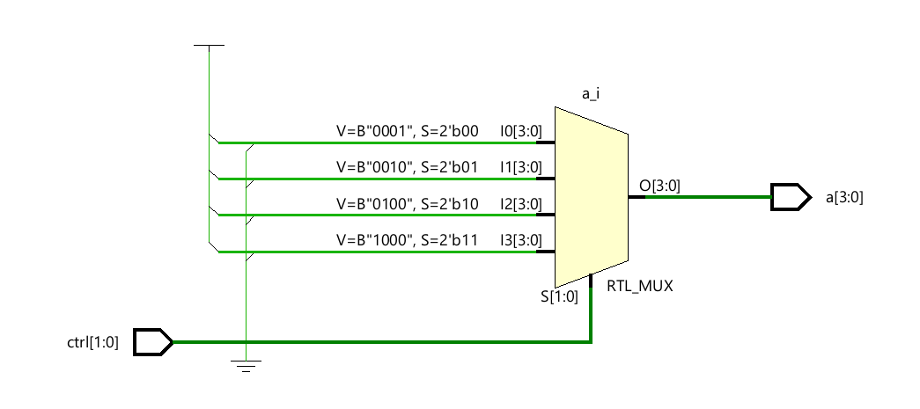
Schematic Analysis: Mapping Components to VHDL Code
1. Input Control Signal (ctrl[1:0])
- Schematic: Displays 'ctrl[1:0]' as the 2-bit input to the multiplexer (RTL_MUX).
- VHDL: Matches with:
- Purpose: Selects the active output line based on the input.
2. Multiplexer (RTL_MUX)
- Schematic: Shows four input lines (I0, I1, I2, I3) into the multiplexer.
- VHDL: Implements selection using:
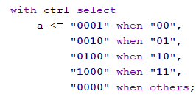
3. Input Values to Multiplexer
- Schematic Inputs: I0 = "0001", I1 = "0010", I2 = "0100", I3 = "1000".
- VHDL Outputs: Match the expected one-hot output patterns.
4. Output Signal (a[3:0])
- Schematic: Displays output as 'a[3:0]'.
- VHDL: Matches:

Comparison Between My Diagram and Schematic
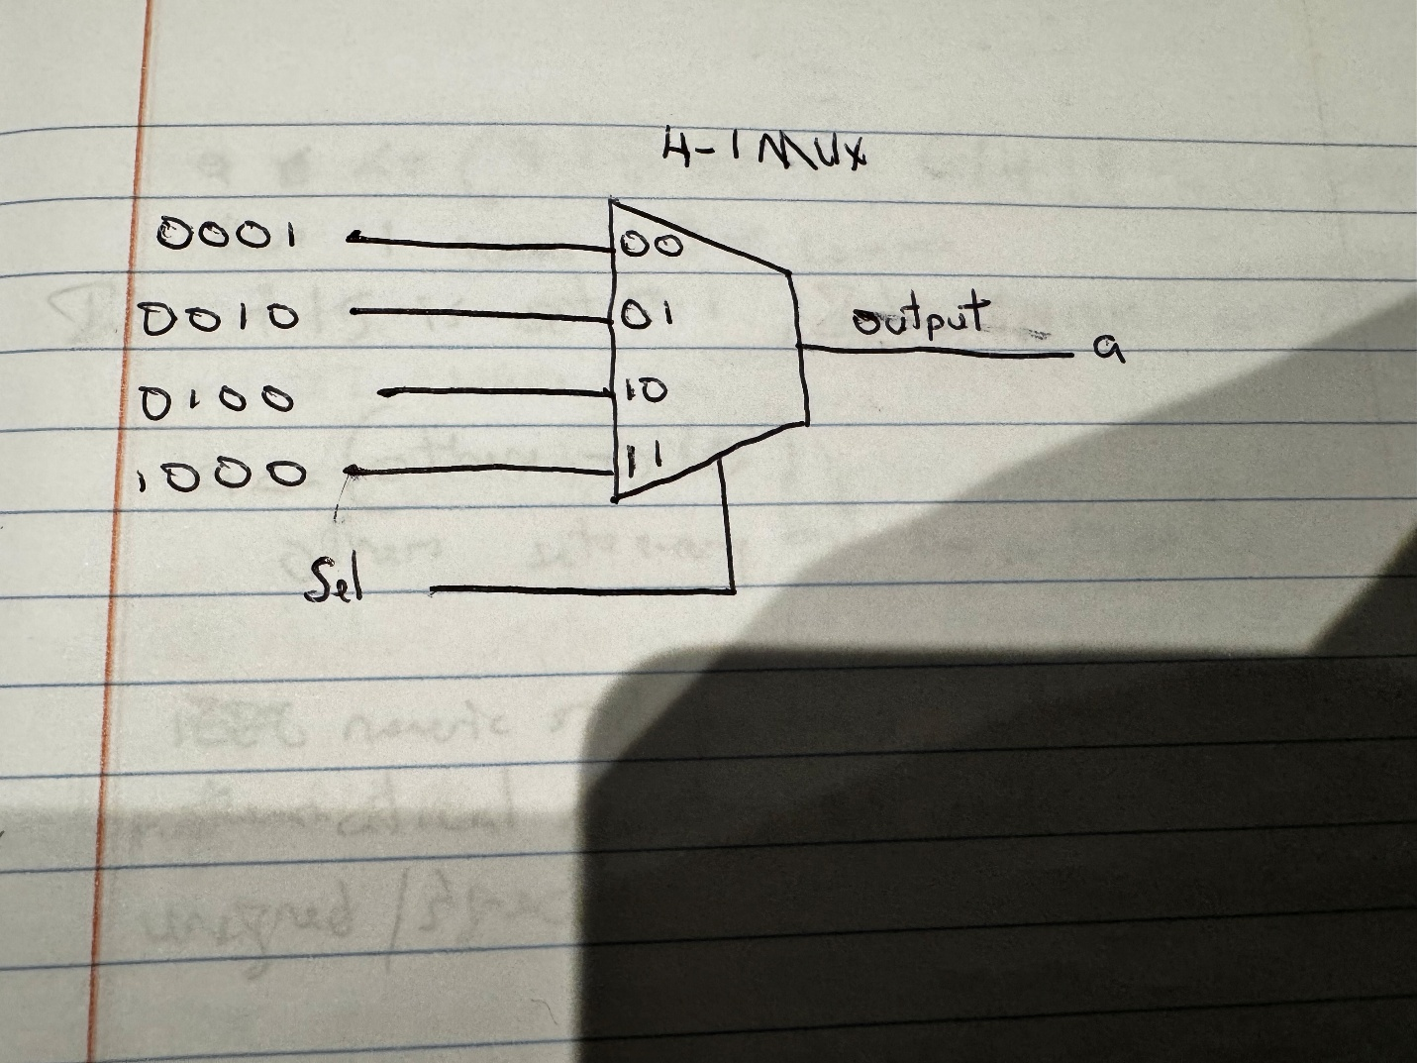
- Similarity: Both the hand-drawn diagram and the RTL elaborated schematic represent a 4-to-1 multiplexer structure with four input patterns and one output (a). The input patterns (0001, 0010, 0100, 1000) match exactly in both representations.
- Difference: In the hand-drawn diagram, the inputs are represented visually in a simplified MUX format, while the schematic explicitly shows the RTL_MUX component with labeled inputs (I0, I1, I2, I3) and control signal (S[1:0]). The RTL schematic also includes additional details such as bit-width labels and signal directions.
- Outcome: The RTL schematic aligns perfectly with the expected behavior depicted in the diagram, confirming that the VHDL code functions as a 2-to-4 decoder.
Conclusion
This part of the lab demonstrated how selected signal assignments in VHDL map to hardware components. By comparing our manual diagram with the RTL schematic, we confirmed the correctness of the design and gained a deeper understanding of how digital logic is implemented and represented through VHDL.

Part 2
Introduction
In Part 2 of Lab 4, we implemented a custom logic design unit using selected signal assignments in VHDL. The design combined basic logic gates (AND, OR, NOT) and a 4-to-1 multiplexer (MUX) to produce an output based on a 2-bit selector input. The primary objective was to develop the VHDL code, generate the RTL schematic in Vivado, and compare it with the original schematic provided by the instructor.
Concept
The design consists of three logic gates (NOT, OR, AND) and a 4-to-1 multiplexer. Each gate produces an output that serves as one of the MUX inputs. The multiplexer selects one of these outputs based on the selector input (s[1:0]), resulting in a single output (x). The logic implemented is as follows:
- s = 00: NOT gate output (NOT a1)
- s = 01: Direct input a2
- s = 10: OR gate output (a1 OR a2)
- s = 11: AND gate output (a1 AND a2)
Procedure
- Created a new project in Vivado, ensuring that VHDL was selected and the Basys 3 board was chosen.
- Using the base VHDL Code provided, wrote the code to implement the schematic of the design unit provided. Debugged the code multiple times to ensure accuracy of schematic result.
- Added the design file to the project and included the Basys 3 Constraint file.
- Clicked 'Run Linter,' then clicked 'Open Elaborated Design.'
- Opened the schematic and identified the components of the schematic and their relationship to the code.
- Compared the schematic generated in Vivado to the original schematic provided by the instructor.
- Ended Part 2.
Comparison between Provided Design & Vivado Schematic
The Open Elaborated Design from Vivado closely aligns with the instructor-provided schematic in structure and logic. Both designs feature the same components: a NOT gate, OR gate, AND gate, and a 4-to-1 multiplexer with proper input-to-output mapping based on the selector 's[1:0]'. The multiplexer correctly routes outputs from the gates according to the VHDL code. The only notable differences are in the naming conventions and additional labels that Vivado automatically generates (e.g., tags such as RTL_INV, RTL_OR, and RTL_AND for the gates). These differences are purely cosmetic and do not affect the functionality or logic of the circuit. Overall, the comparison confirms that the VHDL implementation accurately produces the intended hardware design.

Identification of Components in Schematic Corresponding to VHDL Code
1. Inputs (a1, a2, s[1:0]):
- Schematic: Displays inputs feeding the logic gates and MUX.
- VHDL:
- Purpose: a1 and a2 are fed into logic gates, while s[1:0] controls the MUX.
2. NOT Gate (RTL_INV):
- Schematic: Shows a1 as input and NOT a1 as output.
- VHDL:
- Purpose: Produces NOT a1 for s = "00".
3. OR Gate (RTL_OR):
- Schematic: Shows a1 and a2 as inputs, with their OR result as output.
- VHDL:
- Purpose: Produces a1 OR a2 for s = "10".
4. AND Gate (RTL_AND):
- Schematic: Displays a1 and a2 as inputs, with their AND result as output.
- VHDL:
- Purpose: Produces a1 AND a2 for s = "11".
5. Multiplexer (RTL_MUX):
- Schematic: Displays four inputs from the gates and s[1:0] as the selector.
- VHDL:
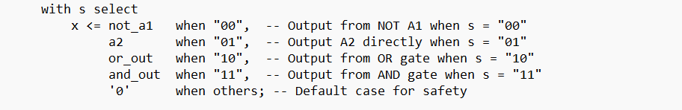
- Purpose: Selects one of the four inputs based on s[1:0] and outputs it to x.
6. Output (x):
- Schematic: Displays x as the final output from the MUX.
- VHDL:
- Purpose: Outputs the selected logic result from the MUX.
Conclusion
In this part of Lab 4, we successfully implemented a custom logic unit using selected signal assignments in VHDL and compared the generated schematic with the instructor-provided design. The comparison revealed that the Vivado-generated schematic matched the provided design, verifying the correctness of our VHDL implementation. This exercise helped reinforce the relationship between VHDL code and its corresponding hardware representation.

